Changing permissions to forward email from [dataupload_fgc@glimpsemarkets.com](mailto:dataupload_fgc@glimpsemarkets.com)

1. Go to www.office.com and log into the tenant which hosts the email address that we want to forward mail from. (do not log into the destination email address tenant)
2. Open the **Admin Center**
3. Next, click **Show All (admin centers)** and then click **Security**.

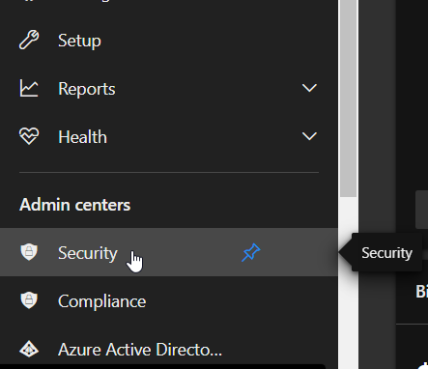

1. Next, in the Security / Microsoft 365 Defender Admin Center, under Email & Collaboration, click on **Policies & rules**.

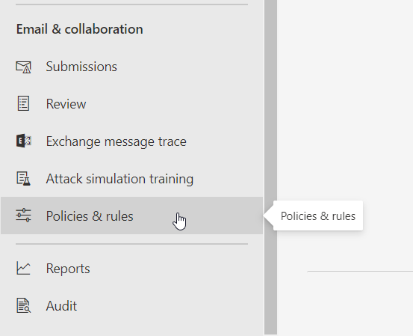

1. Here, click on **Threat Policies**

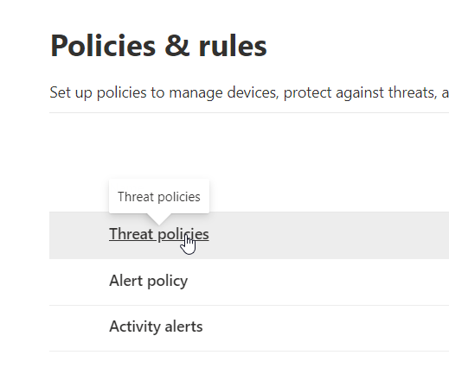

1. Under Threat policies, click Anti-Spam.

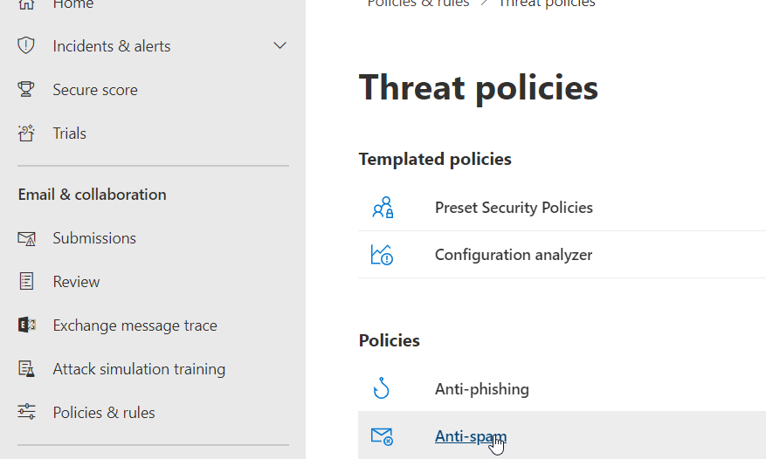

1. Under the Default **Anti-Spam** outbound policy (Default) we will probably find **Automatic Forwarding** is set to **Automatic – System-Controlled**

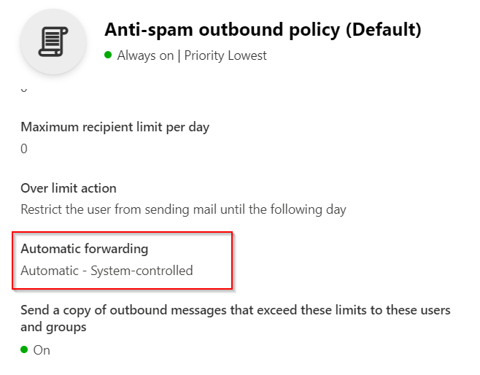

1. Close the Default Policy and then at the top of the screen click the + **Create Policy** drop-down and choose **Outbound**

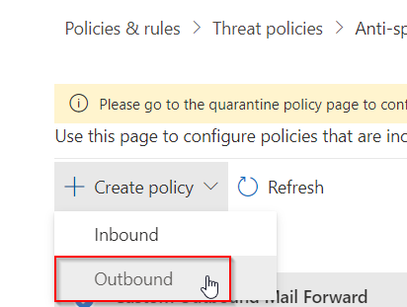

1. In the new Outbound policy, edit the description to something like “**Custom Outbound Mail Forward**“, and add the Users or Groups to the policy (whom you want to give the ability to forward.)

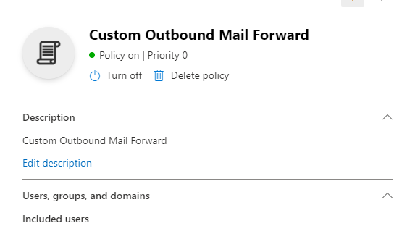

1. At the bottom of the new custom policy change Automatic Forwarding to: **On – Forwarding is enabled**

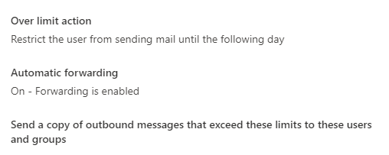

1. Save and close the new policy and that should do it. Try sending some test messages to see if the forward works correctly. We may need to change the new policy’s Priority to 0 if something still isn’t working. Also, don’t forget to double check the Automatic Forwarding on the mailbox itself.